VISVESVARAYA TECHNOLOGICAL UNIVERSITY
Belagavi – 590018
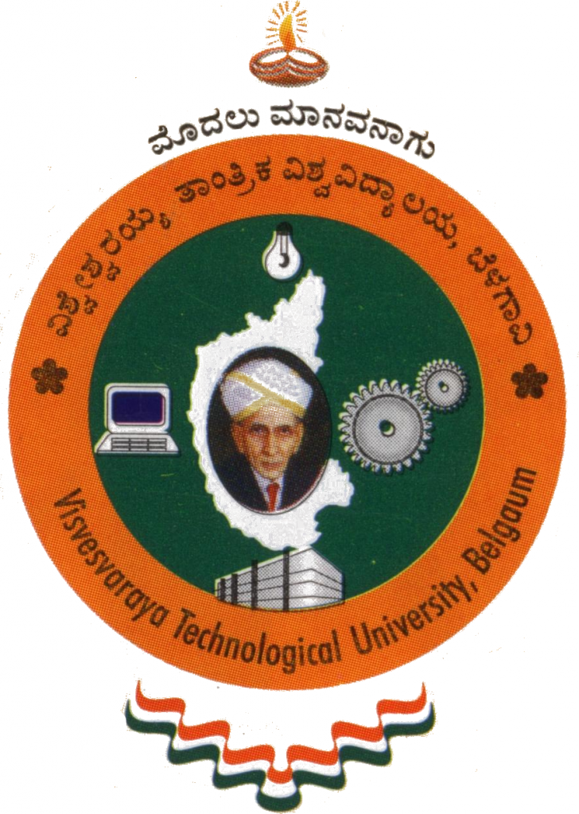
A Project Report on

FLOOD PREDICTION USING AI
Submitted by
AJAY KARTHIK | 4SN17CS700
CHAITANYA THEKKUNJA | 4SN17CS711
KISHAN KASHYAP | 4SN17CS714
SHUBHANG | 4SN17CS723

In partial fulfillment of the requirements for the degree of
BACHELOR OF ENGINEERING
IN
COMPUTER SCIENCE & ENGINEERING

Under the Guidance of
Mrs. GANGOTHRI S
Associate Professor


Department of Computer Science & Engineering
SRINIVAS INSTITUTE OF TECHNOLOGY
(NAAC ACCREDITED)
MANGALURU - 574143, KARNATAKA.
2020 - 2021

